**NAME:** RITHIKA N

**SUPERSET_ID:** 6412250

**WEEK 1:** DESIGN PATTERNS AND PRINCIPLES

**TASK 2:** Implementing the Factory Method Pattern

**Scenario:**

You are developing a document management system that needs to create different types of documents (e.g., Word, PDF, Excel). Use the Factory Method Pattern to achieve this.

**Steps:**

1. **Create a New Java Project:**
   * Create a new Java project named FactoryMethodPatternExample.
2. **Define Document Classes:**
   * Create interfaces or abstract classes for different document types such as WordDocument, PdfDocument, and ExcelDocument.
3. **Create Concrete Document Classes:**
   * Implement concrete classes for each document type that implements or extends the above interfaces or abstract classes.
4. **Implement the Factory Method:**
   * Create an abstract class DocumentFactory with a method createDocument().
   * Create concrete factory classes for each document type that extends DocumentFactory and implements the createDocument() method.
5. **Test the Factory Method Implementation:**
   * Create a test class to demonstrate the creation of different document types using the factory method.

**SAMPLE CODE AND OUTPUT AS FOLLOWS:**

Documentt.java

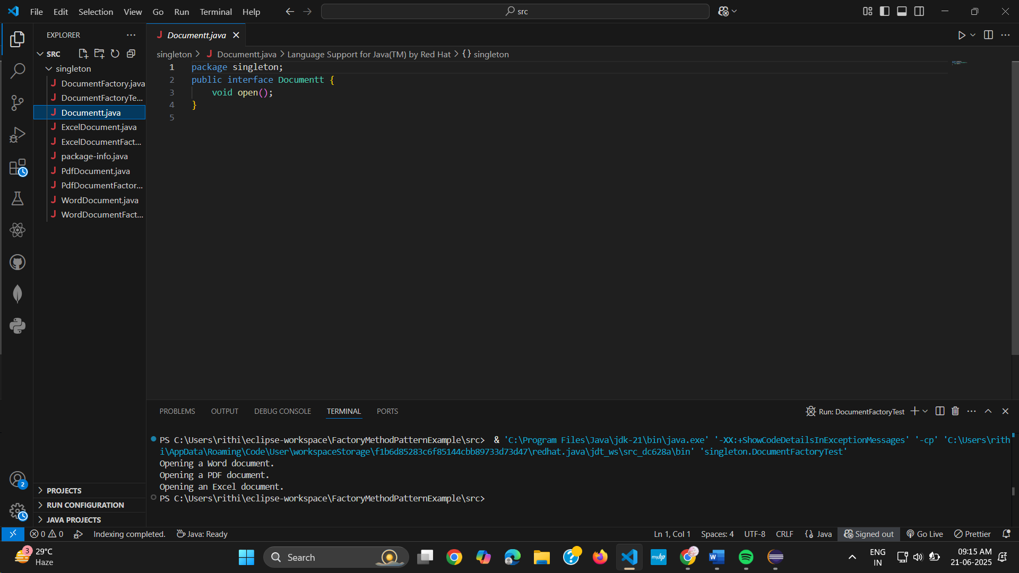

ExcelDocument.java

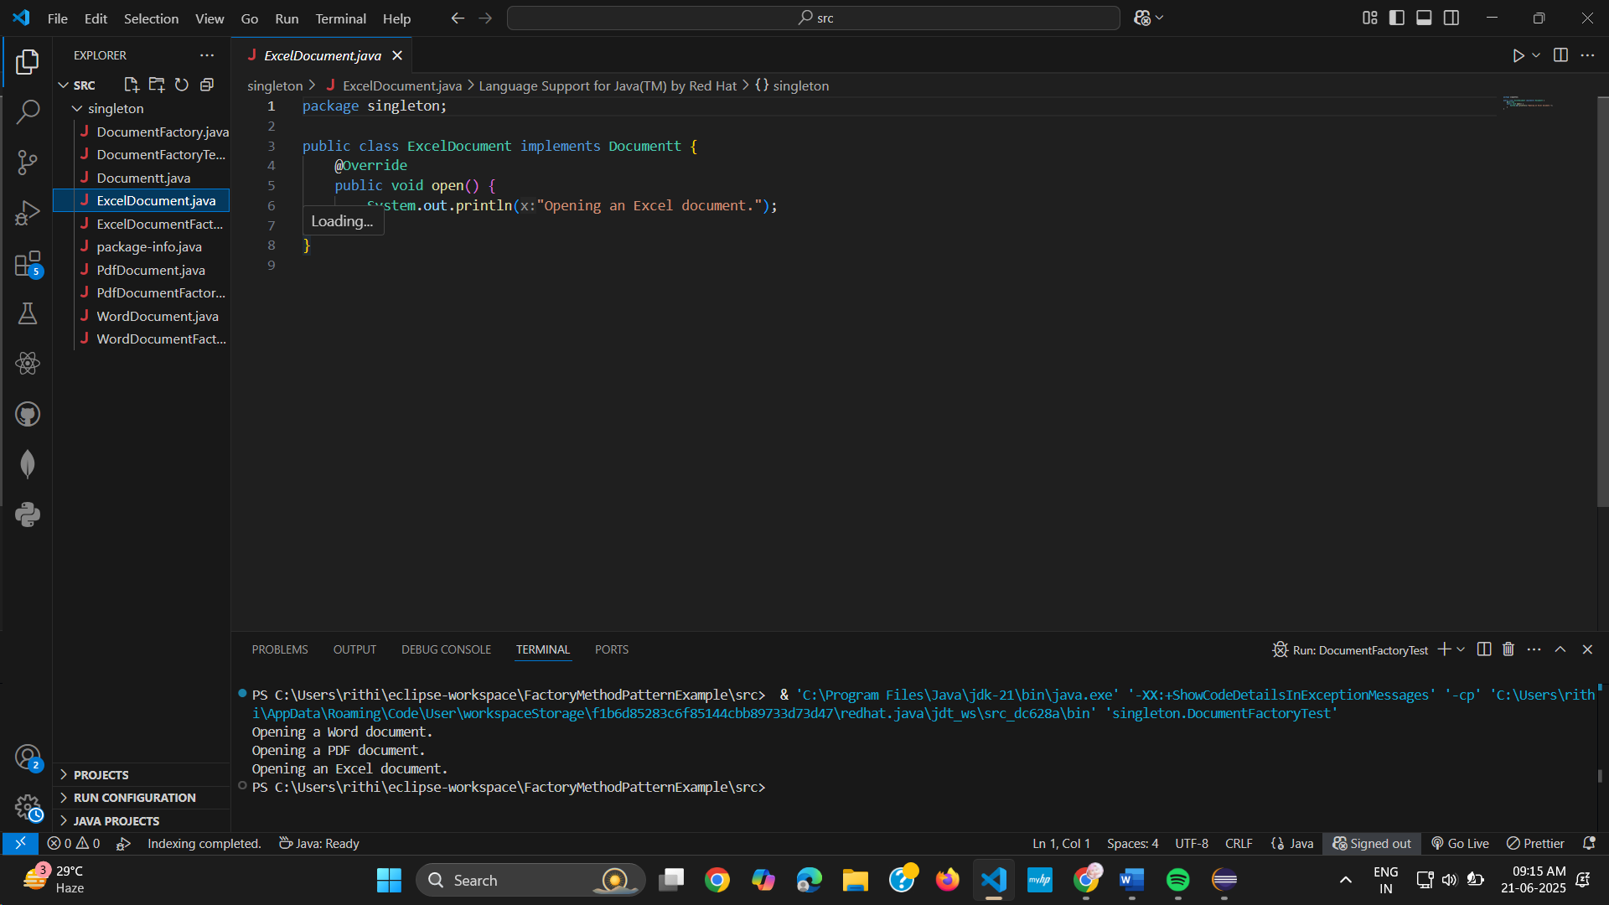

PdfDocument.java

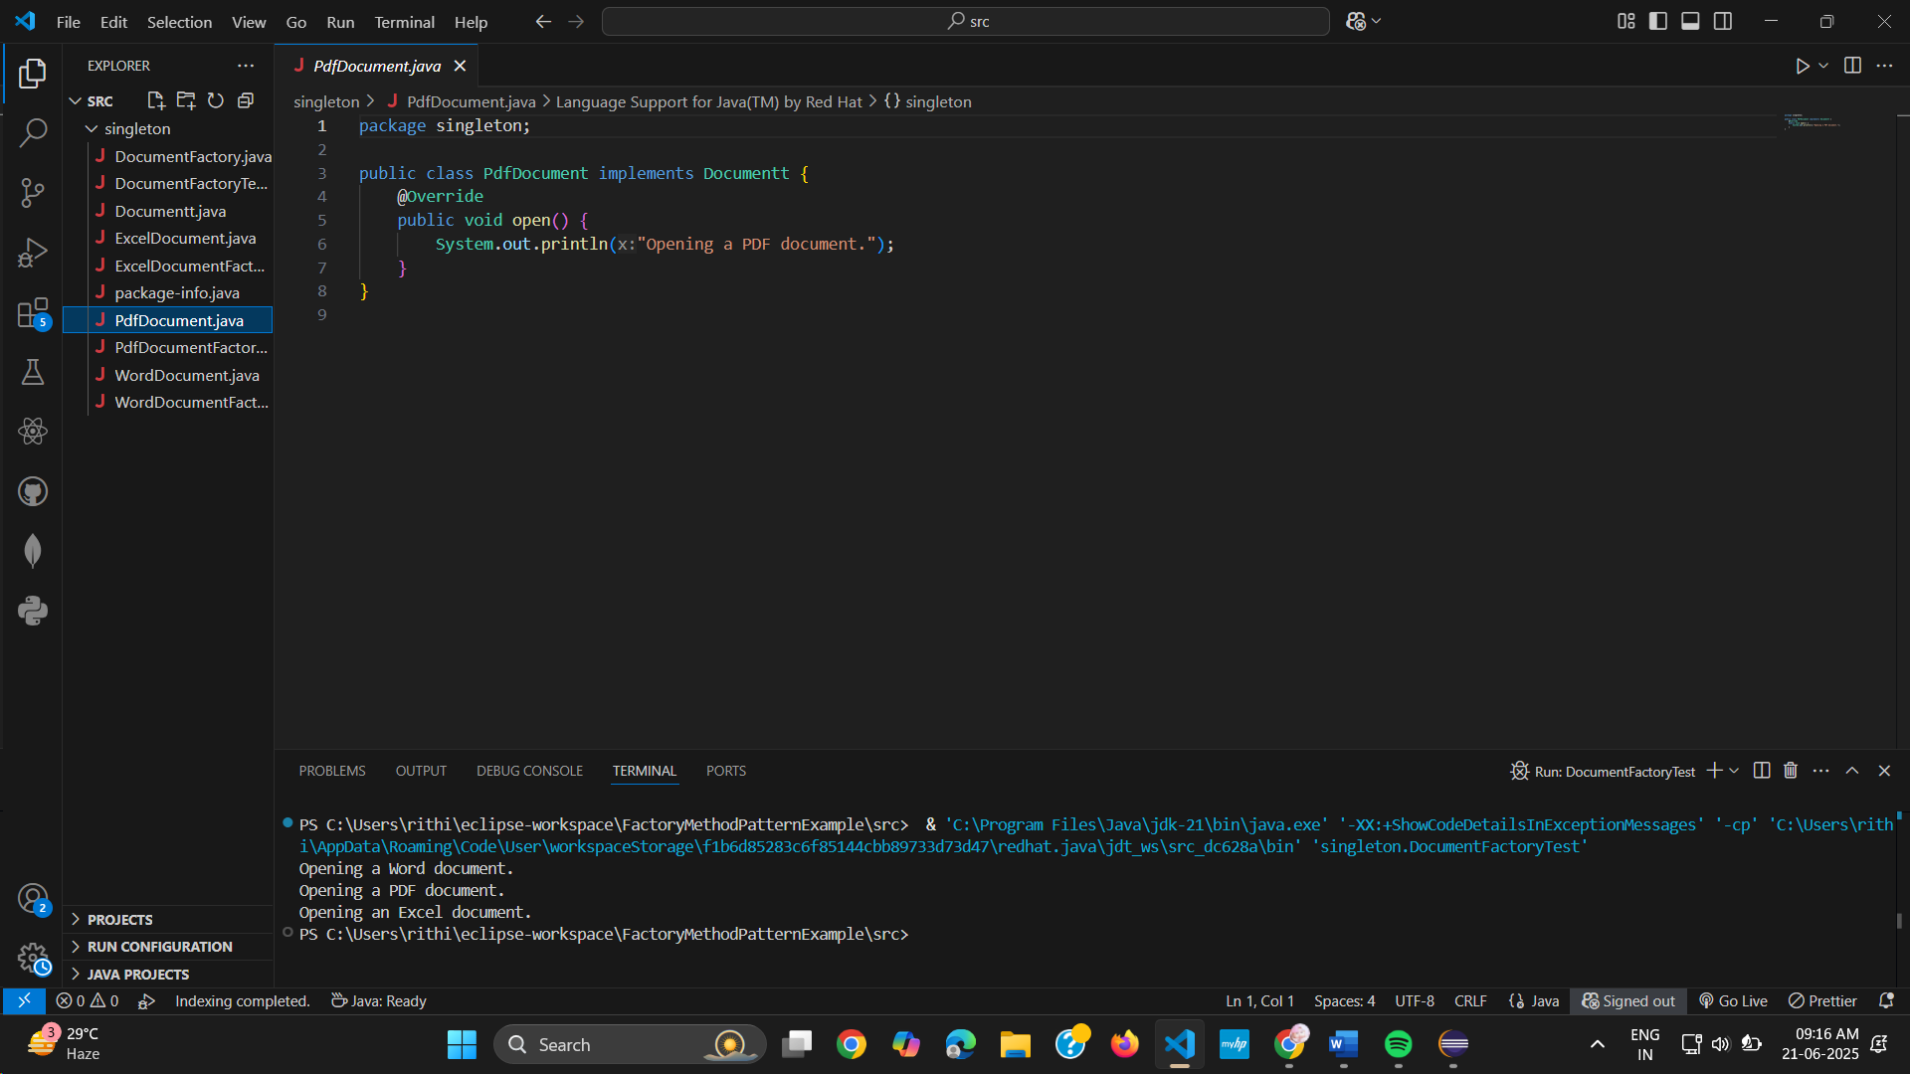

DocumentFactory.java

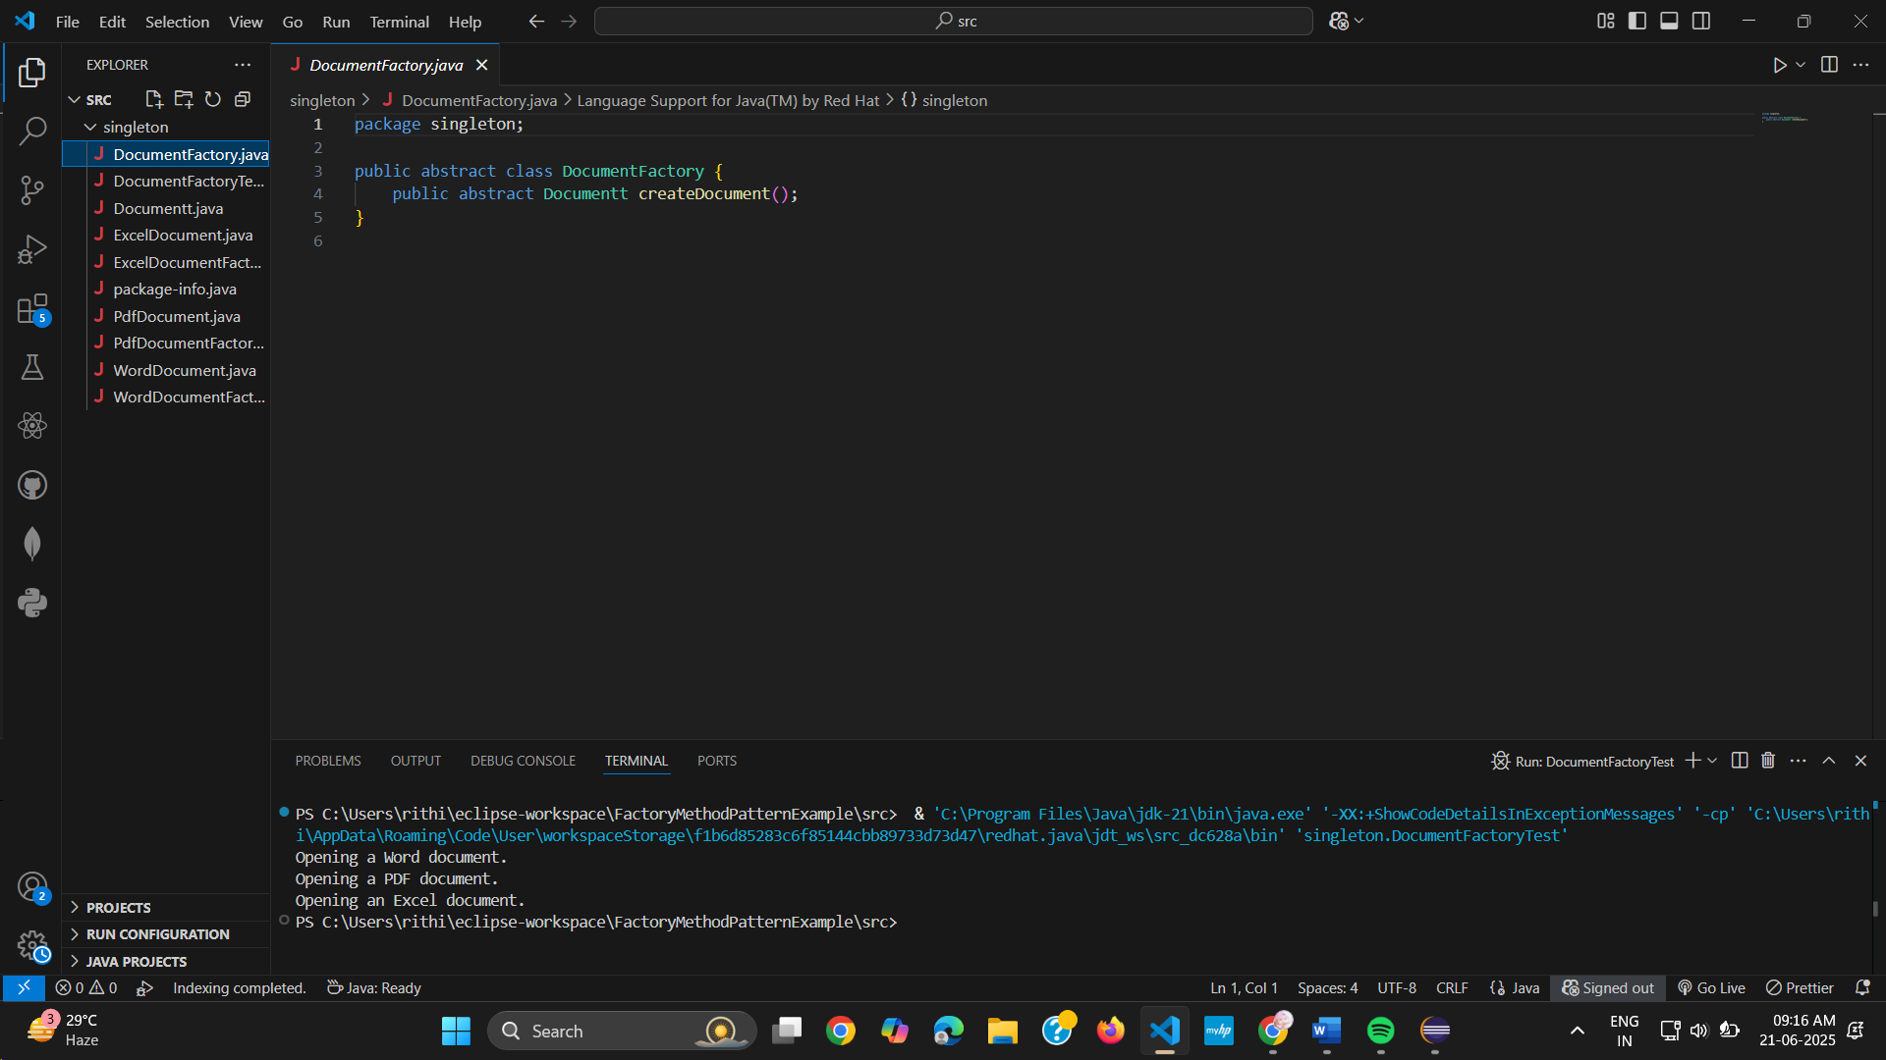

PdfDocumentFactory.java

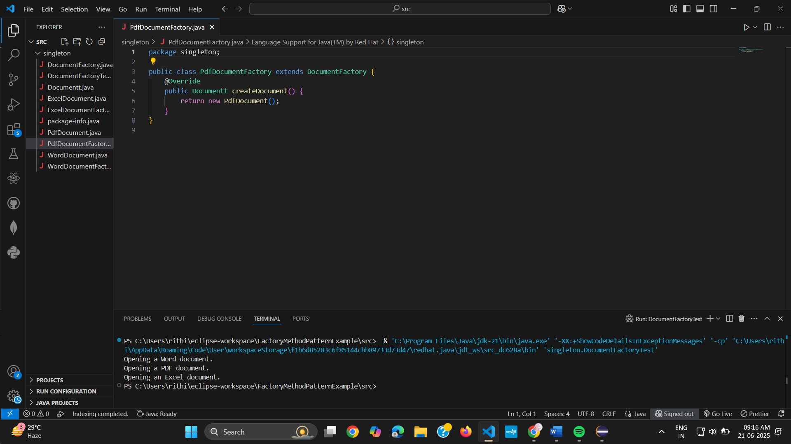

WordDocument.java

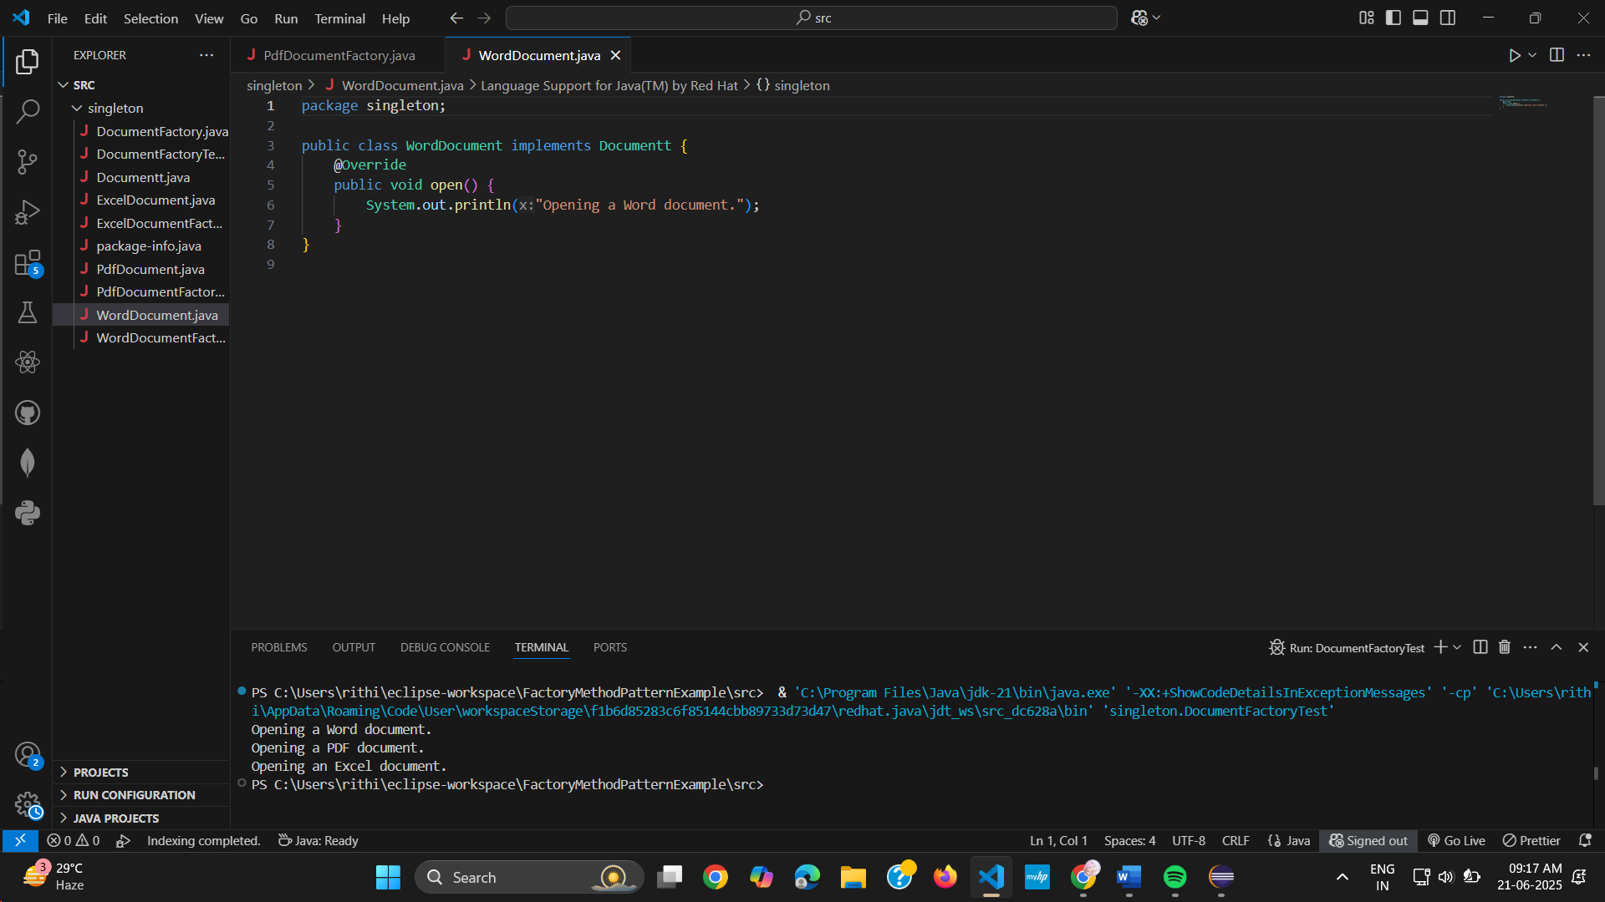

WordDocumentFactory.java

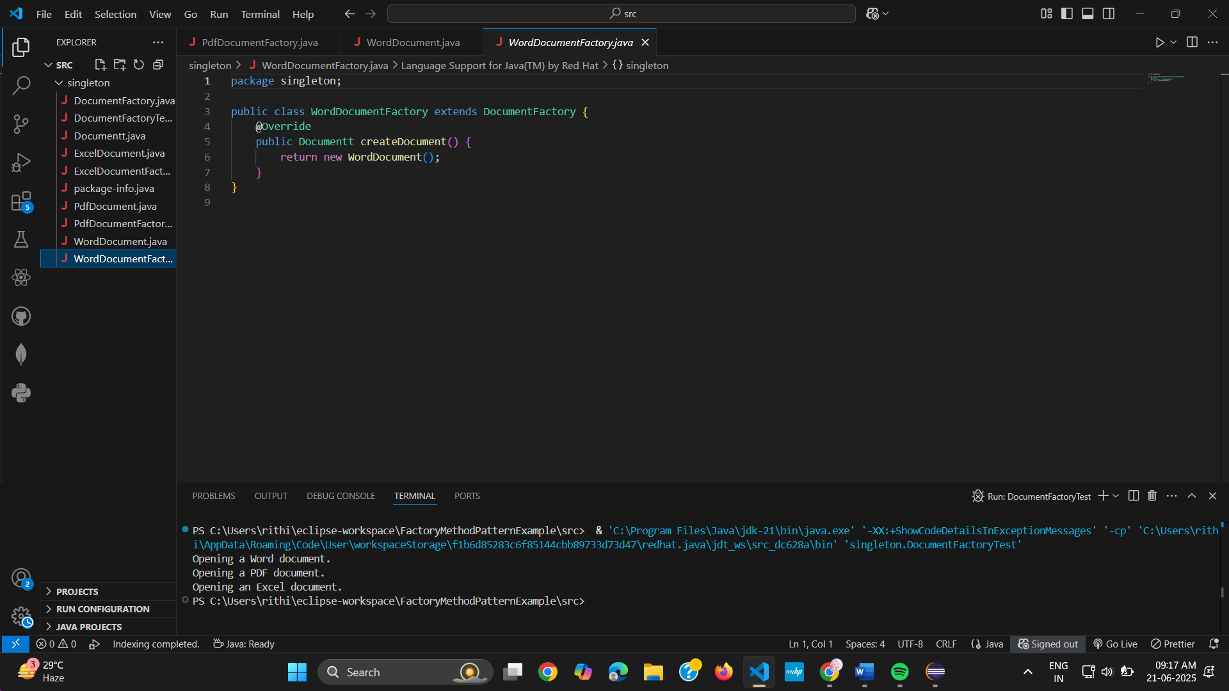

ExcelDocumentFactory.java

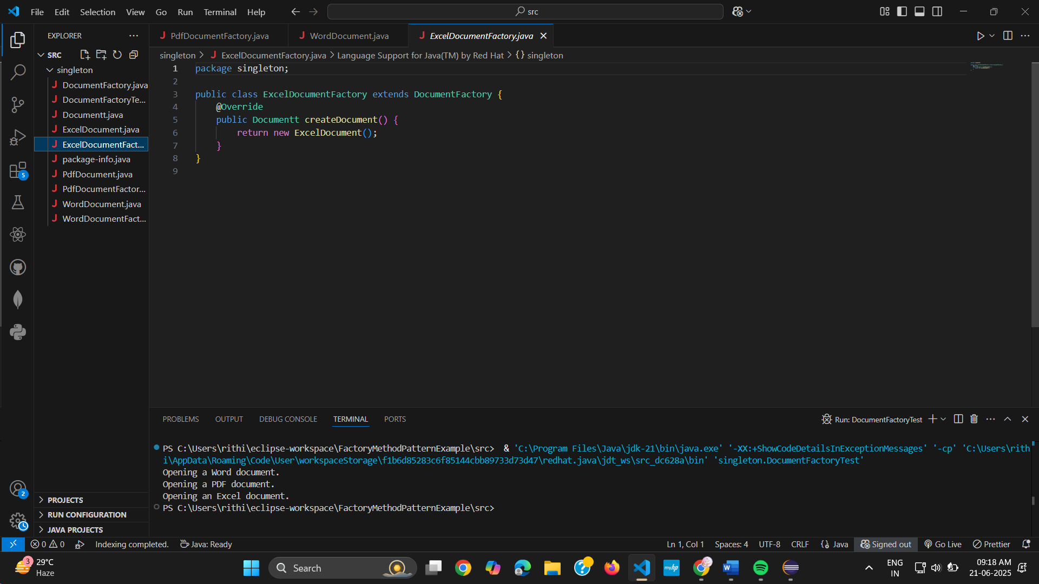

DocumentFactoryTest.java

